EXIT TICKET
1 Look at the picture. Match the words in the table below.
a chair  two mirrors  two carpets  a desk  clothes  a laptop  books  curtains  a clock | on the wall.  in the wardrobe.  in front of the window.  under the bookshelf.  on the floor.  on the window.  next to the bed.  between the pencil box and the lamp.  on the bookshelf.
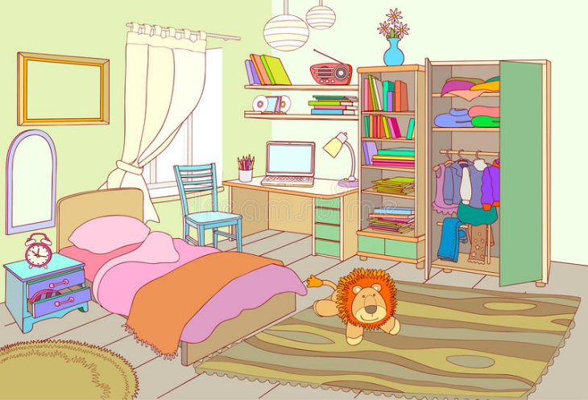

2 Make sentences. Use There is / There are.

1) There is a chair in front of the window.________________________________________________
2) ________________________________________________________________________________
3) ________________________________________________________________________________
4) ________________________________________________________________________________
5) ________________________________________________________________________________
6) ________________________________________________________________________________
7) ________________________________________________________________________________
8) _________________________________________________________________________________
9) _________________________________________________________________________________

