NAME: ________________________
Read the text and complete the tasks. There are two parts.

The Most Amazing Animal in the World
Part 1: Meet Jaz Belo
Jaz Bello is a photographer and a reporter. He works for National Geographic magazine. At the moment, Jaz is writing an article about African elephants. He is staying at Somburu National Park in Kenya. Jaz loves elephants.
He thinks they are the most amazing animals in the world. Every day he gets up early in the morning and hops in the jeep. He drives through the wilderness until he sees a family of elephants. Then he gets out of the jeep,
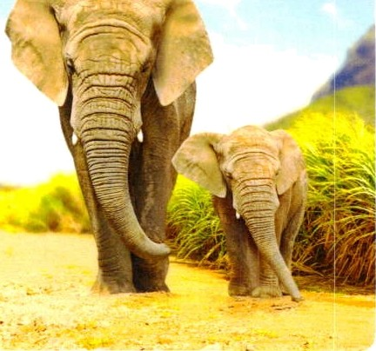
and takes pictures. A few weeks ago an elephant named Umu had a baby. Its name is Lulu.
,

Match ( spoji tako da napišeš brojeve na crtu):

- Kenya is a baby elephant.

- National Geographic is an elephant mum.

- Jaz is a magazine.

4 Umu is ____ a country in Africa.

5 Samburu is _____national park.

6 Lulu is a photographer and a reporter.

Part2: African elephant

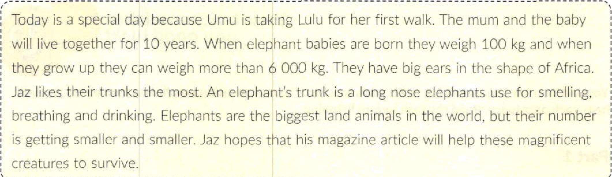

Choose and mark yellow the correct answer. (Označi žuto točan odgovor)

1 Umu is taking Lulu for ______
- her first walk. b) her first swim. 2 Umu and Lulu will live together for ___years.
a) 5 b) 10
- Baby elephants can weigh ... when tney are born.
a) 100 kg. b) 1000 kg.
- Elephant ears are shaped like_____

c) her first lunch.
c) 15
c) 6000 kg.

  - Asia. b) Africa. c) Australia.
5 An elephant's trunk is a long ______elephants use for smelling, breathing and drinking.
a) leg b) arm c) nose
- Elephants are ________ land animals in the world.

  - tne smallest b) the cutest
- The number of elephants in the world is getting
a)smaller and smaller. b) bigger and bigger. c) closer and closer
TOTAL _____/13

- the biggest

